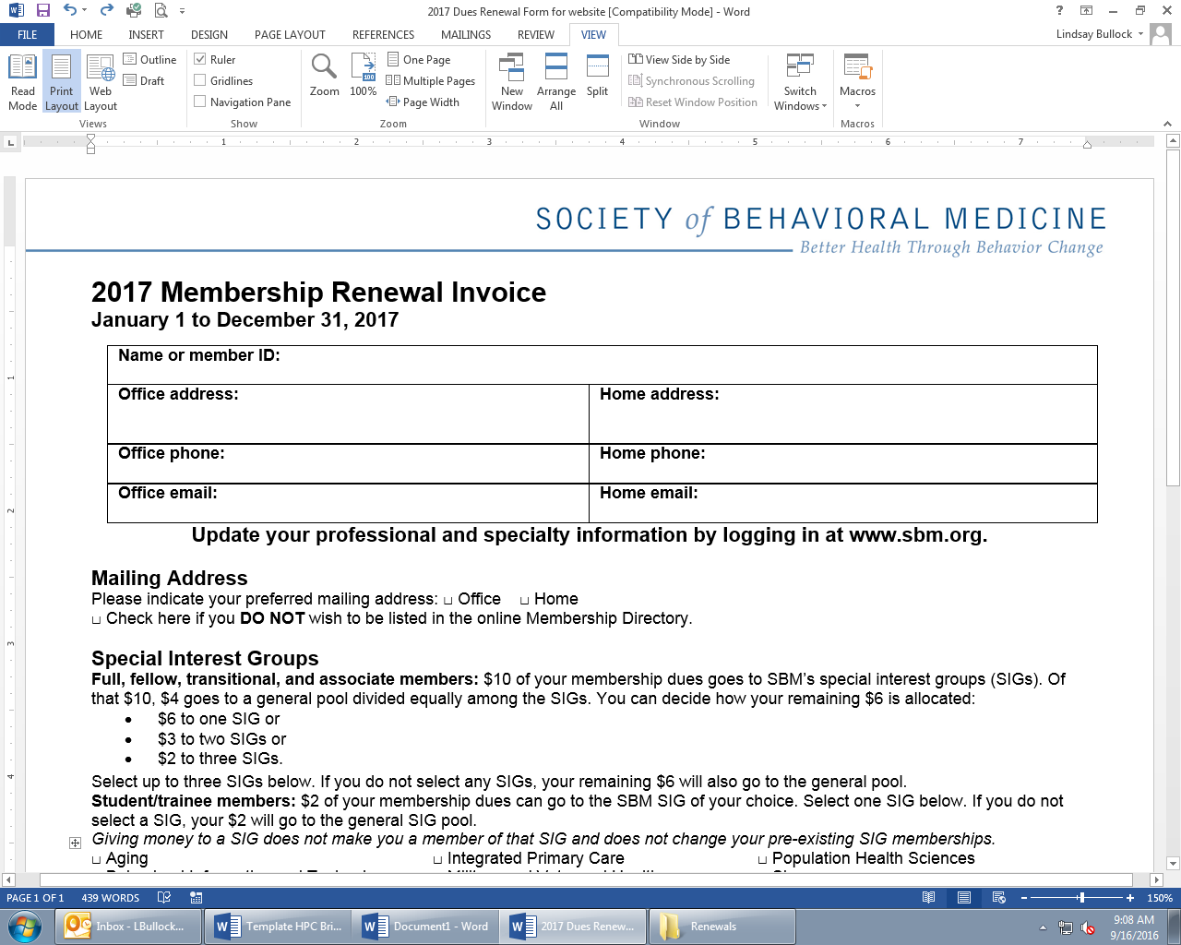

**Health Policy Brief Proposal Form**

To propose a health policy brief, provide the following information and send this completed form to Health Policy Committee Chair Joanna Buscemi, PhD, at [jbuscem2@depaul.edu](mailto:jbuscem2@depaul.edu).

**Summary Statement**  
This should be the main thing you are advocating for. For example: The Society of Behavioral Medicine supports retaining current school lunch standards set by the Healthy, Hunger-Free Kids Act of 2010 to improve the health of children; The Society of Behavioral Medicine supports stronger regulation of electronic nicotine delivery systems (e-cigarettes), incorporation of electronic nicotine delivery systems into clean air policies, and special consideration of product safety standards to protect vulnerable populations.

**Need for the Brief**  
Describe the problem this brief would address, why it is an urgent problem, and why new action is required.

**Assessment of Current Policies**  
Document the need for change by describing the limitations of current policies.

**Policy Recommendations**  
What actions should legislators, clinicians, and/or the public take to address the problem you’ve identified?

**Possible Partnerships**

List any like-minded organizations that may be interested in collaborating on the brief, co-sponsoring it, or endorsing it. Sponsorships and endorsement can dramatically increase the reach of a brief.

**Possible Co-Authors**  
SBM encourages senior- and early-career authors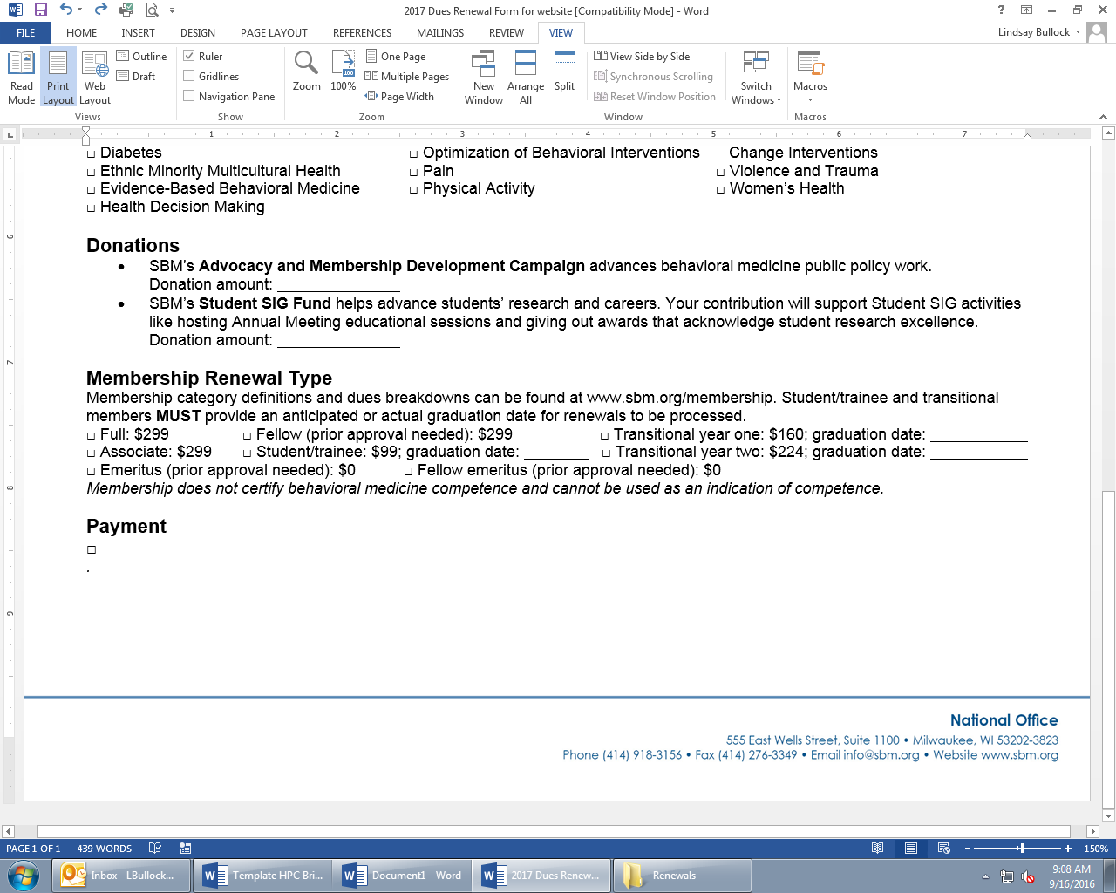 to collaborate on writing briefs as a mentoring opportunity.

**Timeline for Brief Completion**

Writing a brief typically takes 3 months from proposal to final approval. An additional month or two should be added if you intend to seek endorsements or co-sponsorship from other organizations.